GOVT. DR. IONDRAJEET SINGH COLLEGE AKALATARA
DIST. JANJGIR -CHAMPA (C.G.)
NSS 7 DAYS SPECIAL CAMP
FROM 18/11/2024 TO 24/11/2024 AT GOVT. PRIMARY SCHOOL SONDIH (AMALIPALI)
DAY-1 18/11/2024 MONDAY
Reaching at Camp Location – 12:00 noon with 23 Bos & 19 Girls Total 42 NSS Volunteers
Preparation of food and having lunch – 1:45 pm.
Inauguration Ceremony – 2:00 pm.
Chief Guest – Prof B.K.Patel, District Coordinator of NSS, Janjgir-Champa
Chair Person – Dr. Manendra Mehta, Principal, Govt. Dr. Indrajeet Singh College Akaltara
Guest of Honor – Dr. Richa Rathore, Assistant Professor, Shri Sunil Sahu, Assistant Professor, Shri Omprakash Kaiwartya, Guest Lecturer, , Govt. Dr. Indrajeet Singh College Akaltara. Shri Shiv Kumar Singh, Head Master Govt Primary School Sondih and Villagers of Sondih.
Stage Conduction – Dr. Upendra Kumar Verma,NSS Program Officer , Govt. Dr. Indrajeet Singh College Akaltara.
Events – Lightening of lamp, Saraswati Vandana, C.G. State Song, Welcome Song, Welcome Speech, Buquet Presentation to the Guests,
Addressing
By the Chairperson Dr. Manendra mehta on Youth for Digital Literacy.
By NSS Program Officer Dr. Upendra Kumar Verma on Awareness against online fraud and proper use of internet.
By Prof. Sunil Sahu, Assistant Professor on Need of discipline behavior of NSS volunteers to make the camp success.
By Chief Guest Prof. B.K.Patel on Theme and Importance of NSS.
vote of Thanks by Shivesh Kumar Mishra, Senior NSS Volunteer.
Events at Evening session – Group formation and assignment of duties for next day.
Groups –
- VAYU DAL – Sanat Kumar Kashyap, Group Leader (Boys)
Kaleshwari Nayak, Group Leader (Girls)
Jay Kumar Sahu
Praveen Kumar Kaushik
Khileshwari Sonwani
Kriti
Divya
Swagariyata
- AGNI DAL - Ravi Kaiwartya, Group Leader (Boys)
Priyanka Ogrey, Group Leader (Girls)
Nageshwari
Annapurna
Lata Paikara
Dev Nirmalkar
Sitaram
- GAGAN DAL – Rahul Prasad Yadav, Group Leader (Boys)
Annu Sahu, Group Leader (Girls)
Selina Kurrey
Bharti Dongare
Anshika
Masum Bharadwaj
Dulesh Kaiwartya
Mukesh Das
- BHUMI DAL – Jay Kumar Ray, Group Leader (Boys)
Anita Kewat

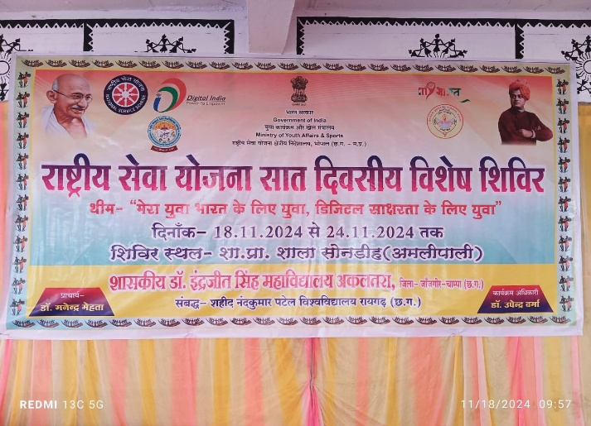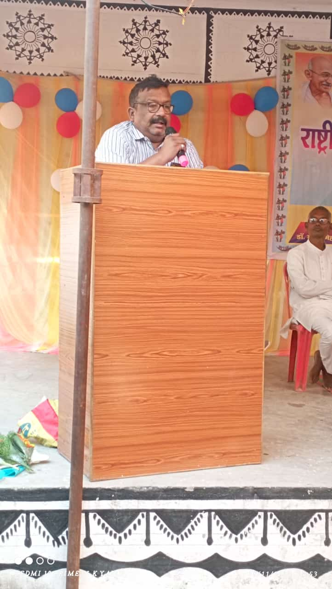
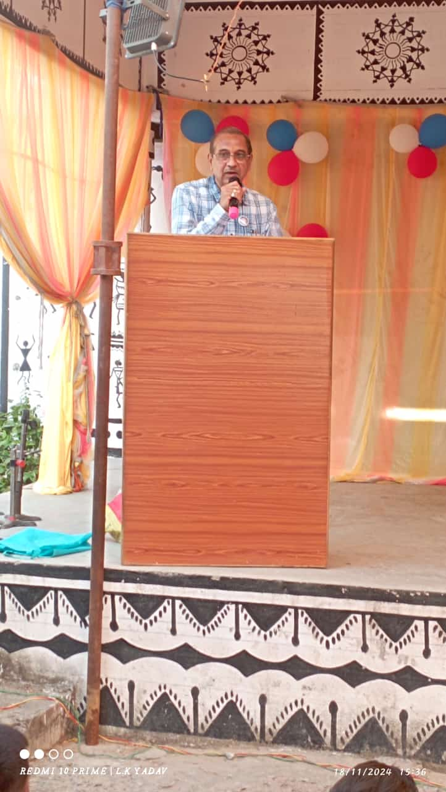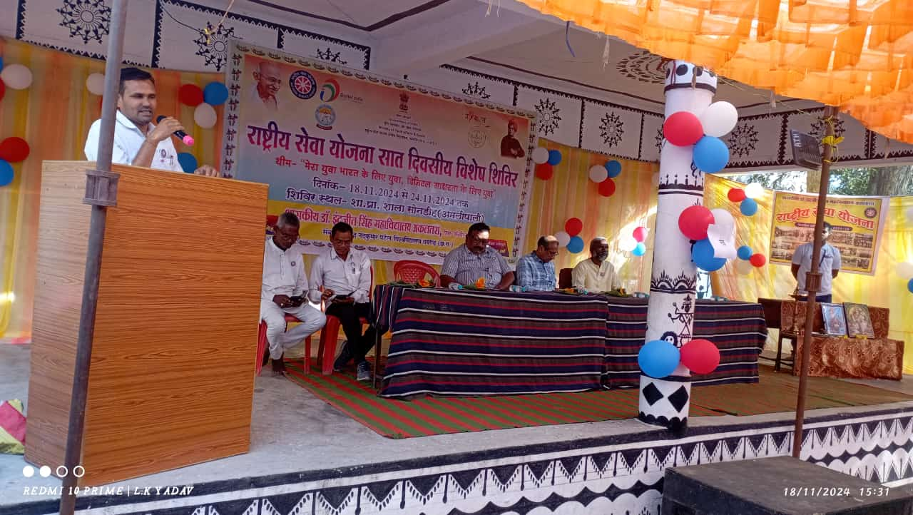
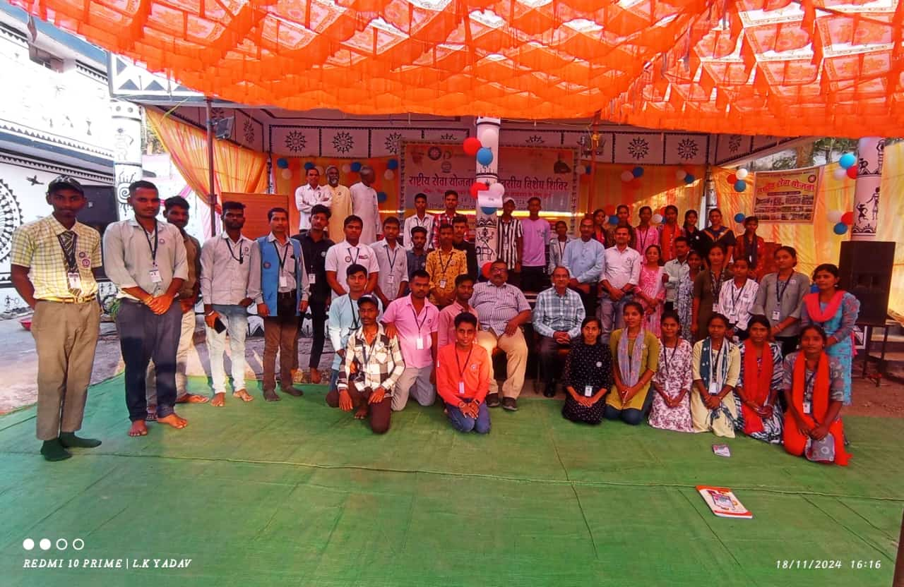
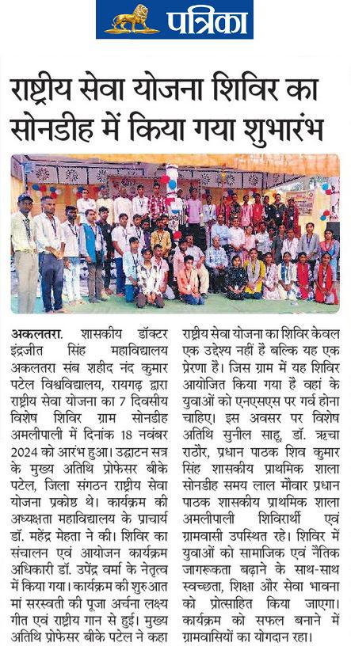
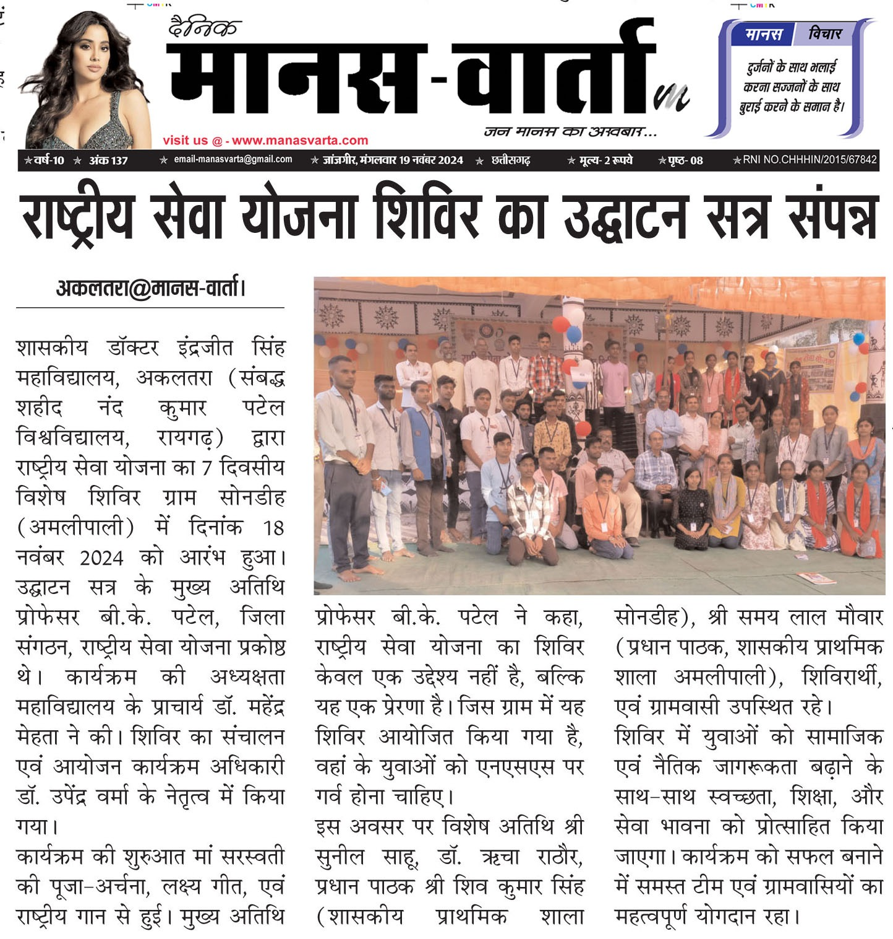
DAY-2 19/11/2024
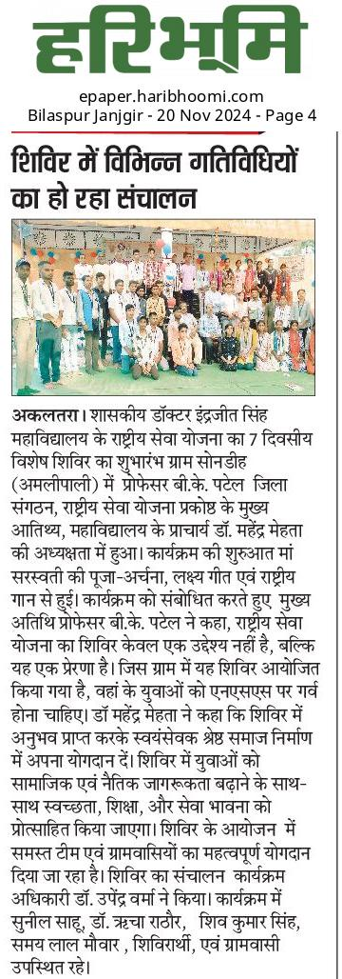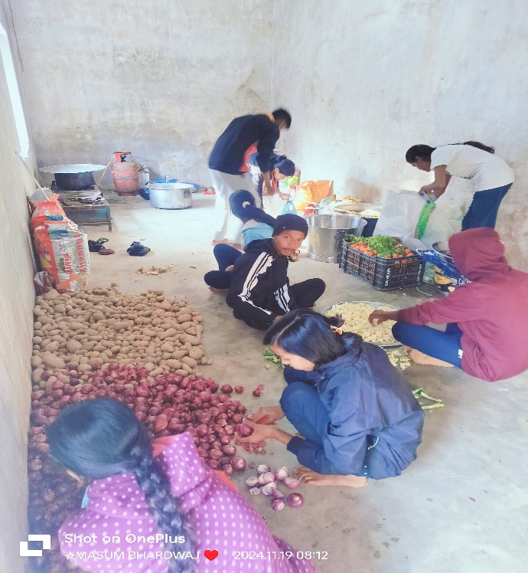
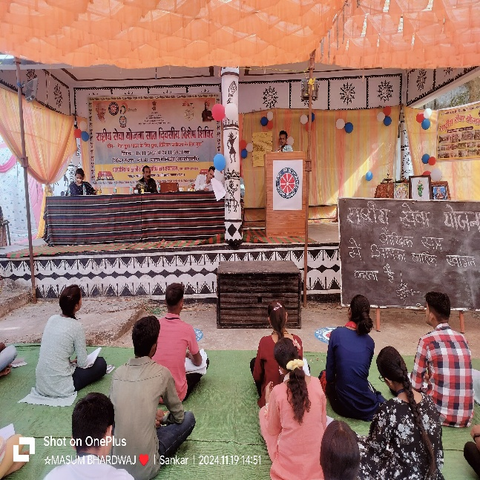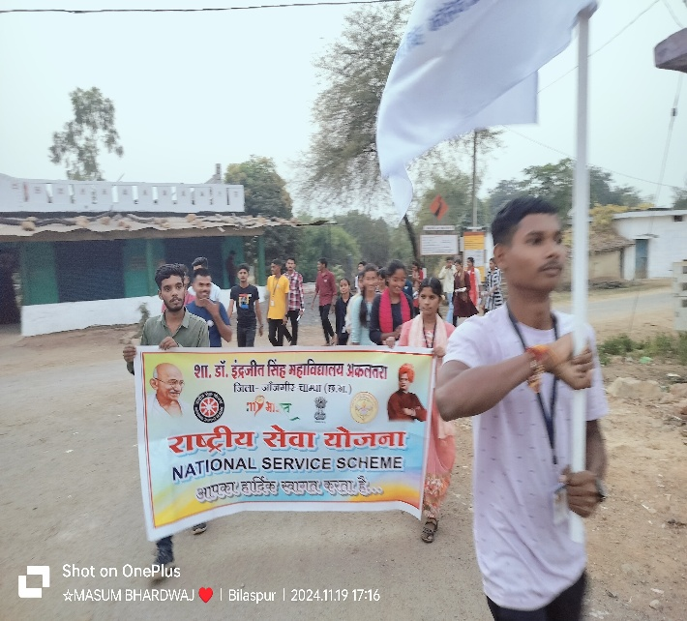
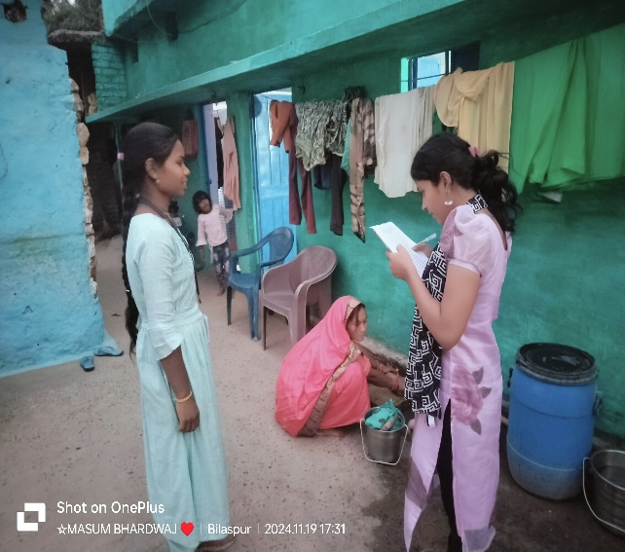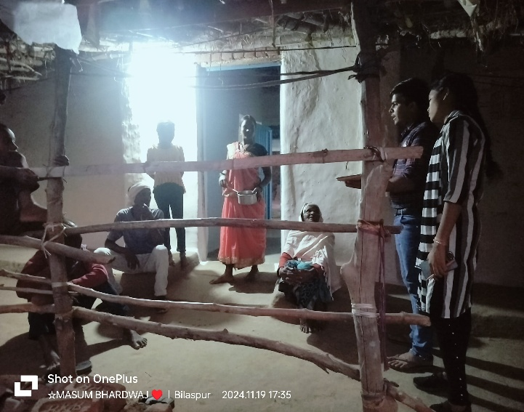
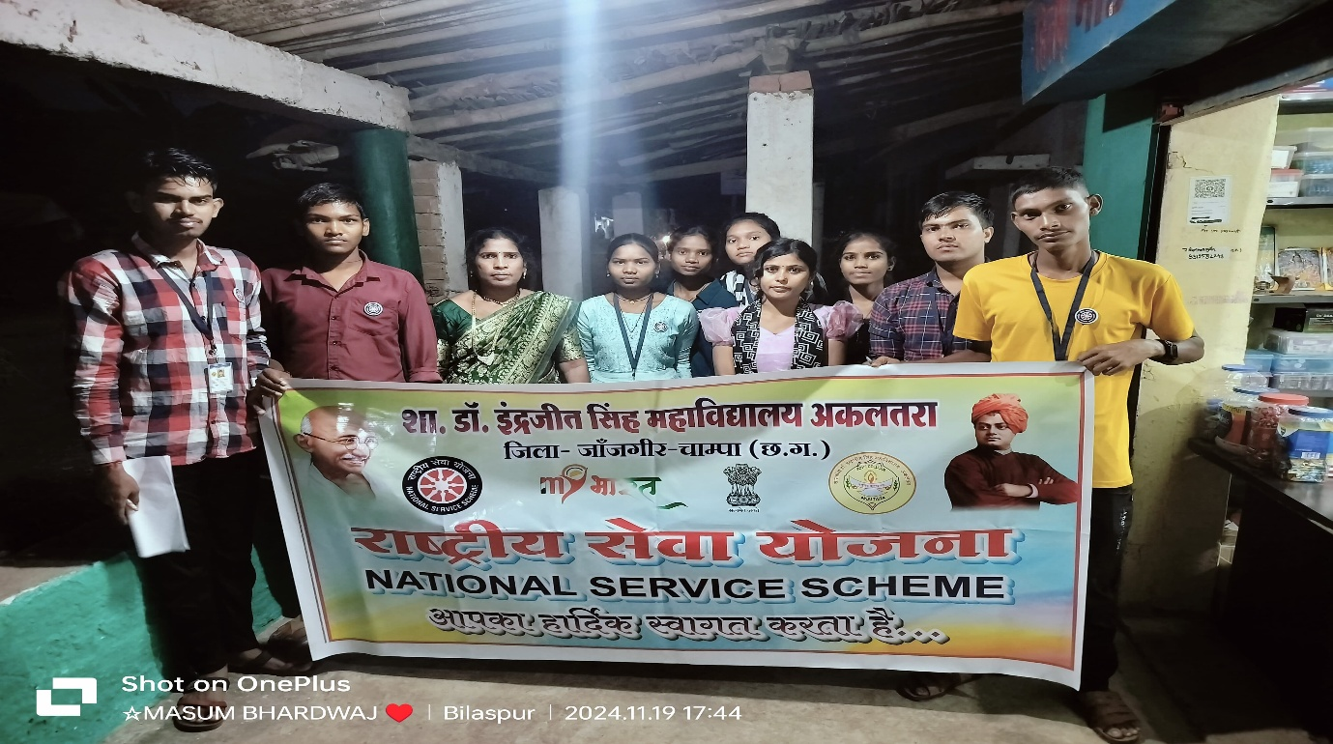
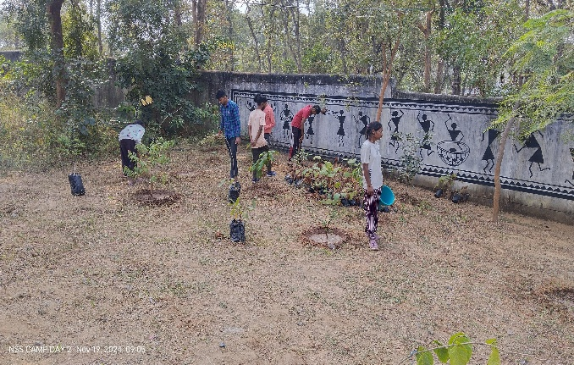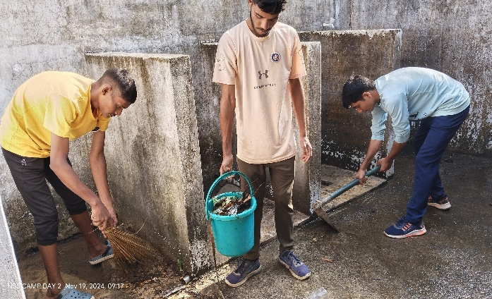
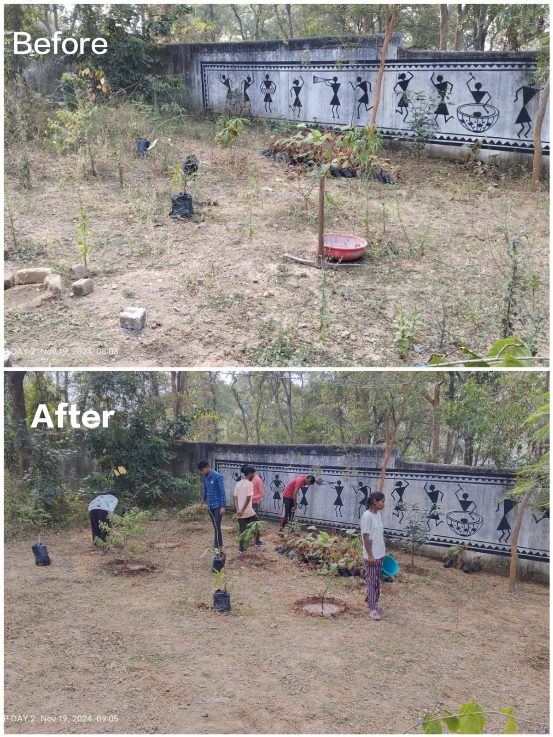
Day-3 20/11/2024
DD News Chhattisgarh
https://youtube.com/live/gbzUGQPgIiM?feature=shared
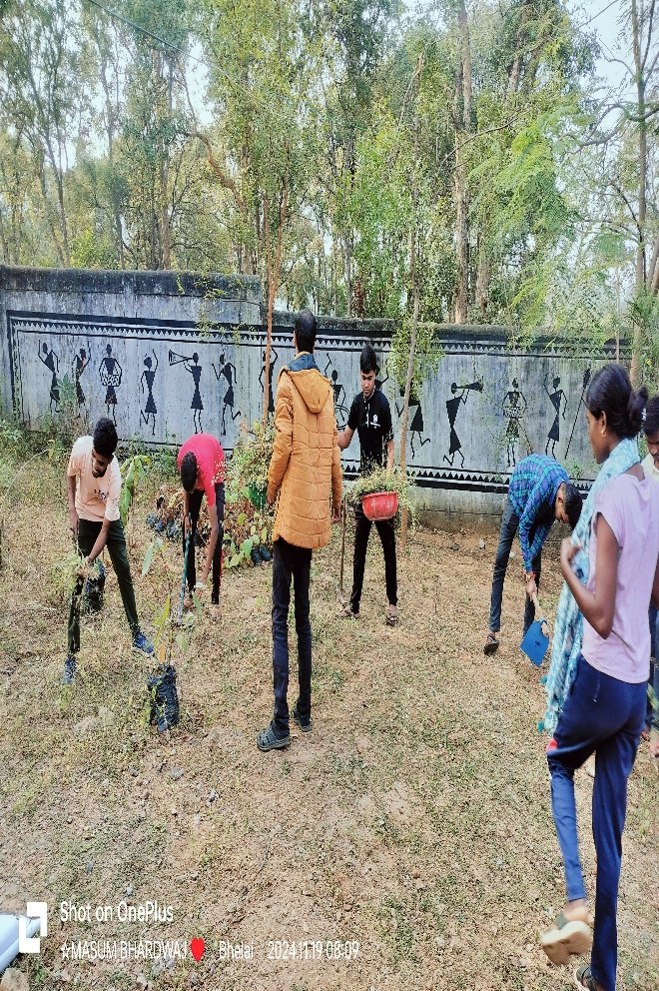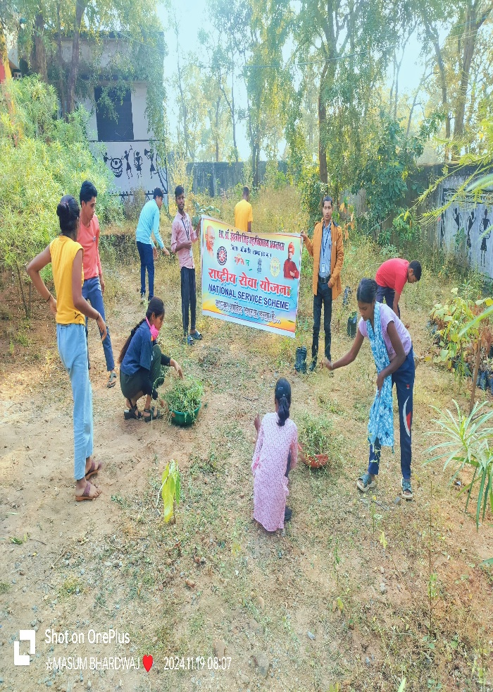
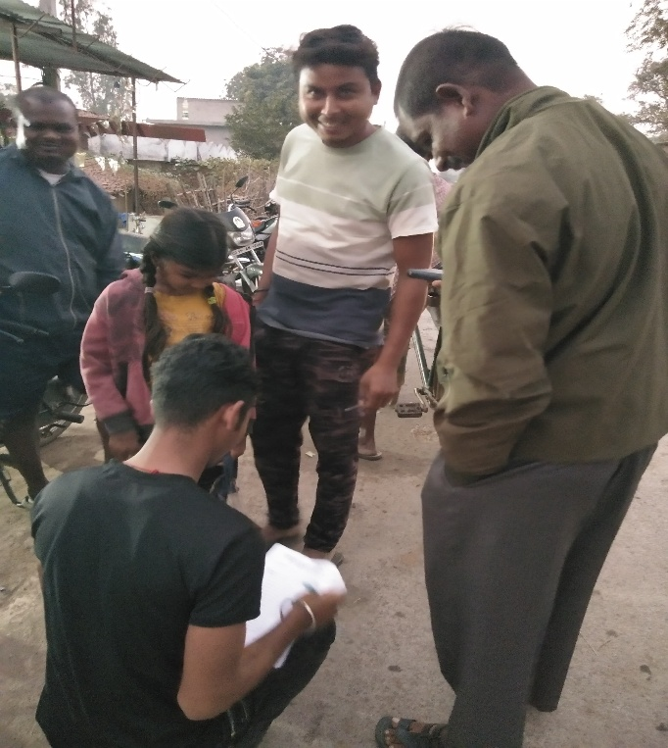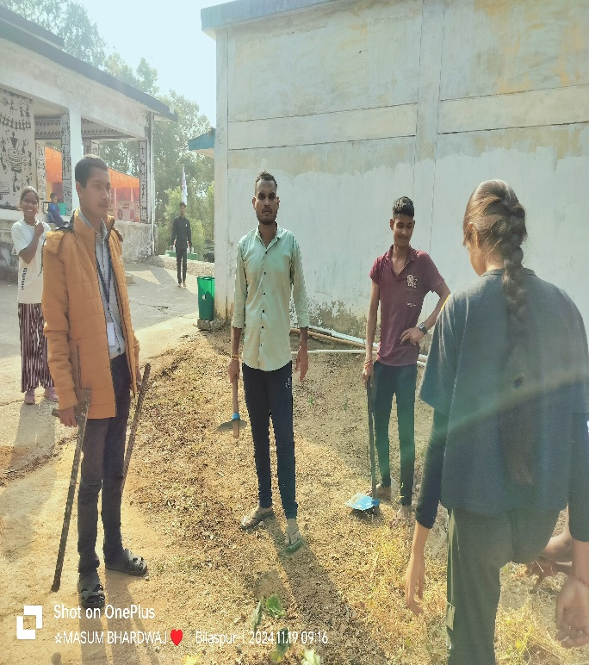
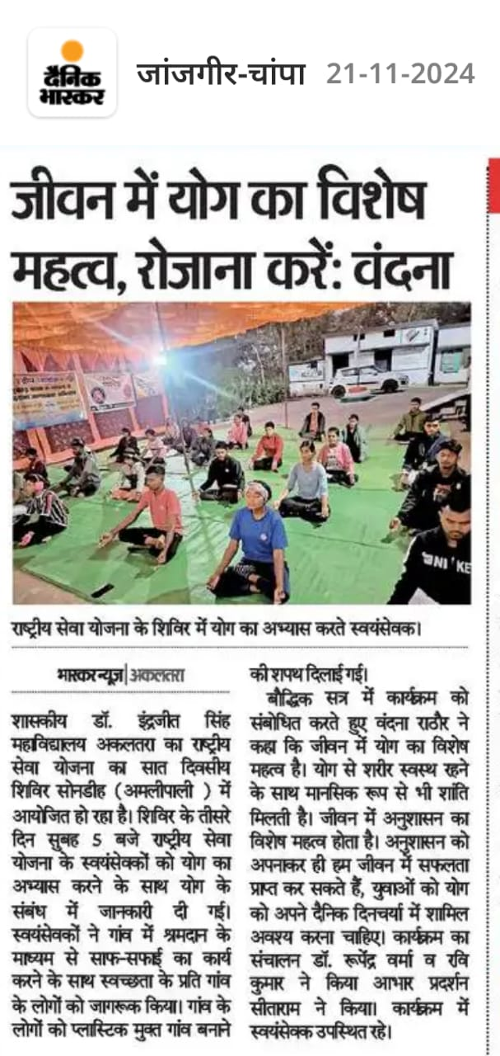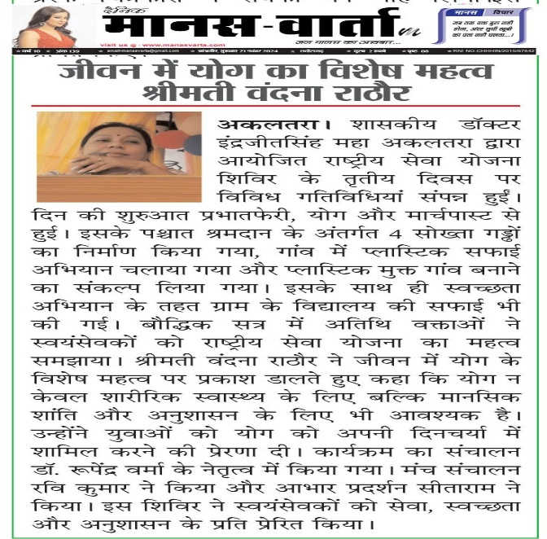
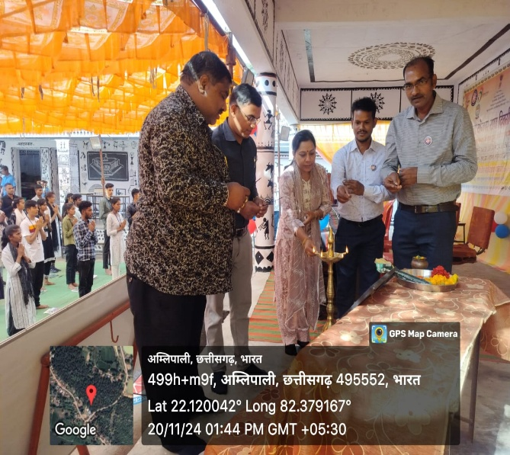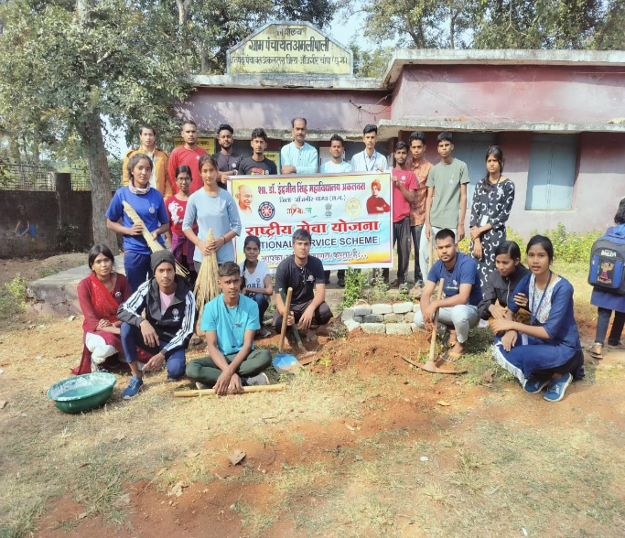
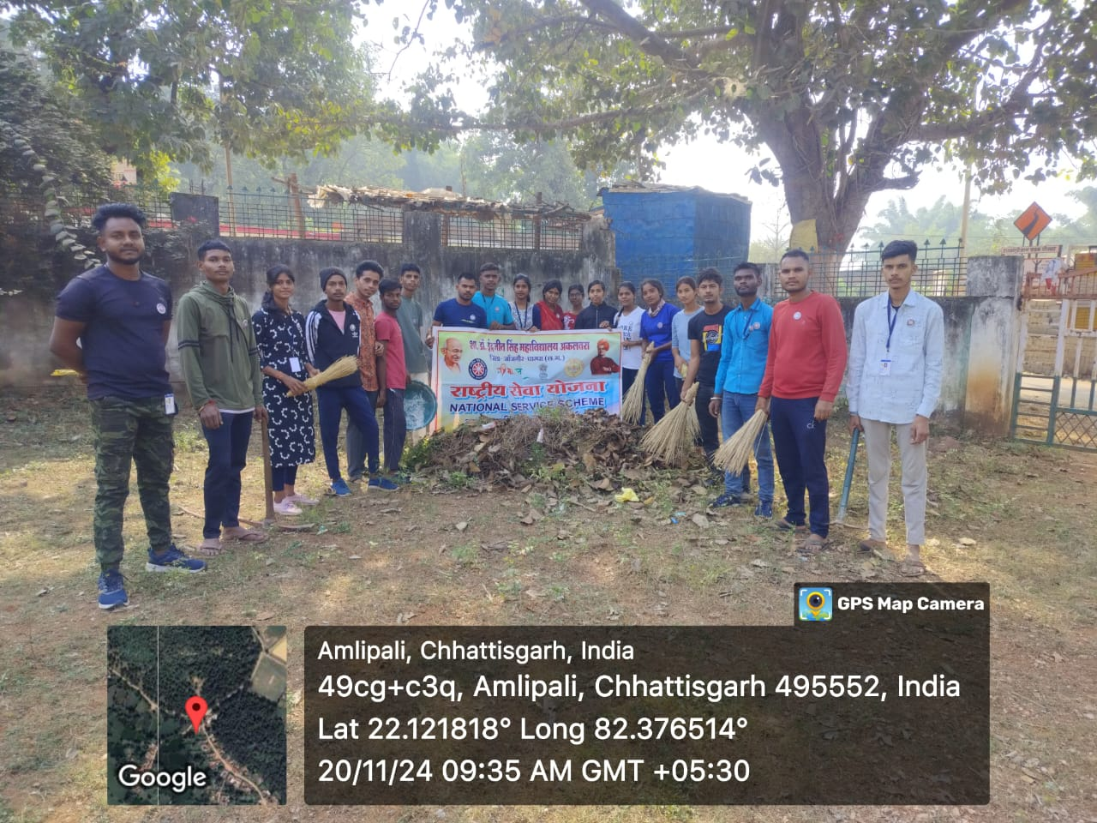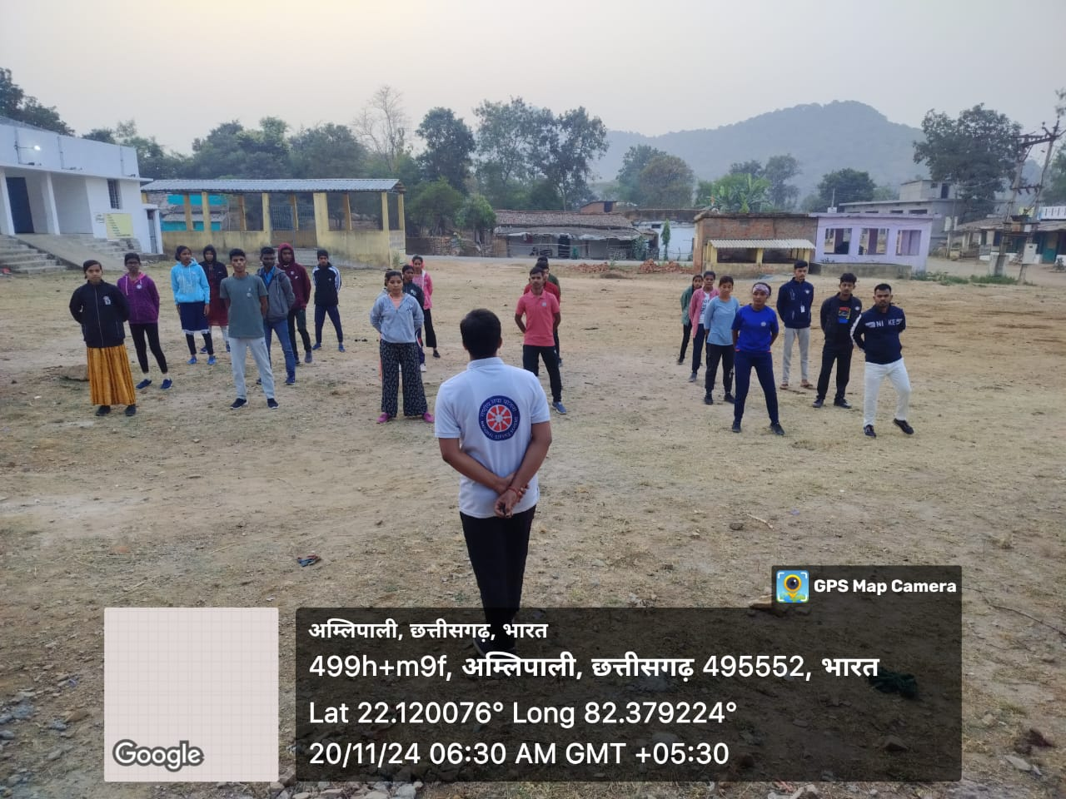
DAY-4 21/11/2024
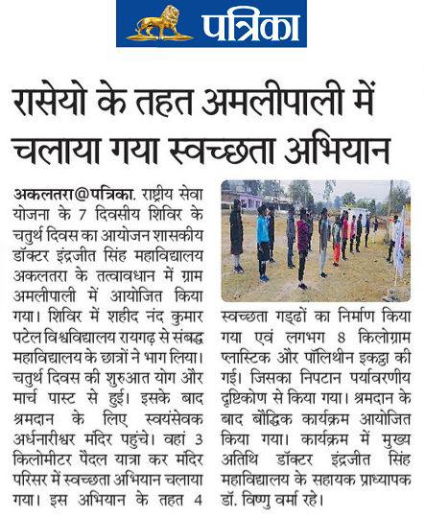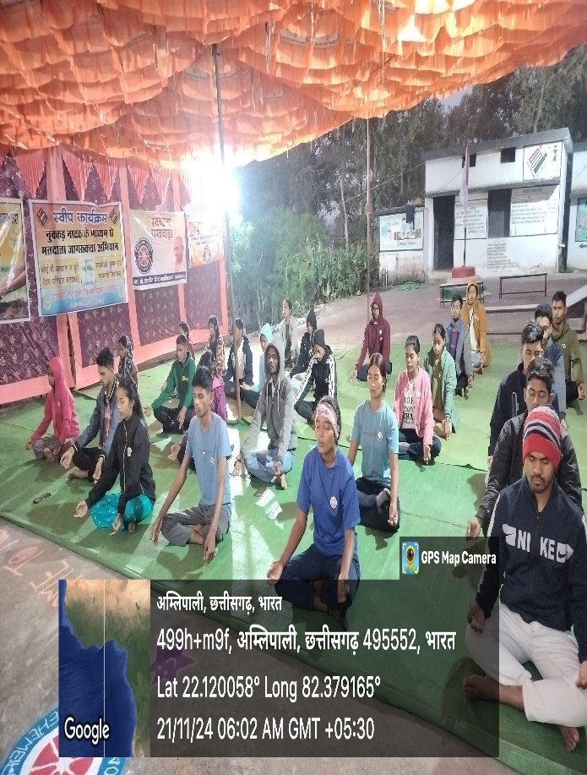
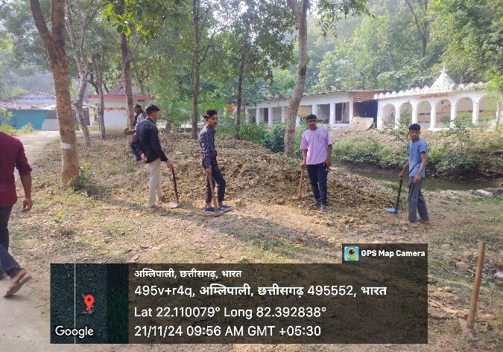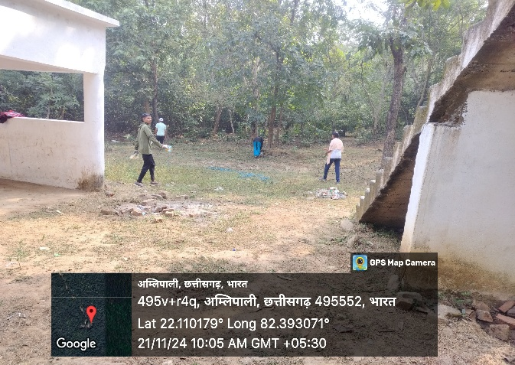
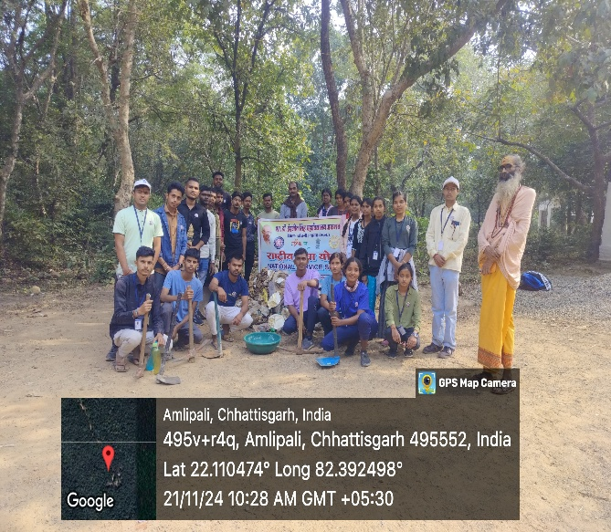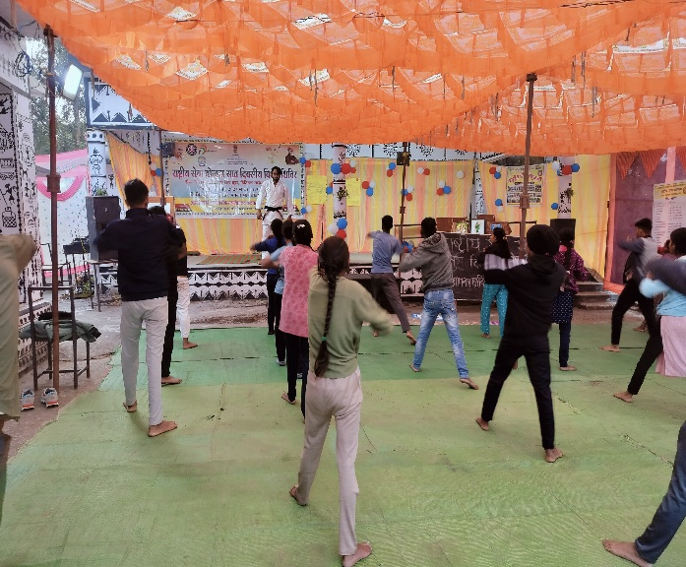
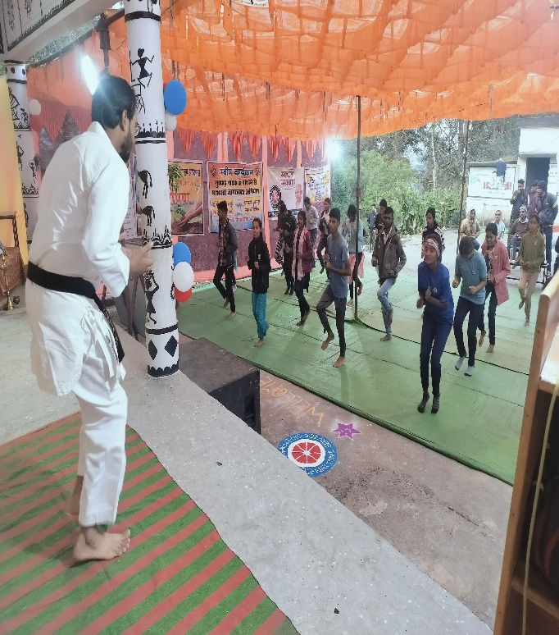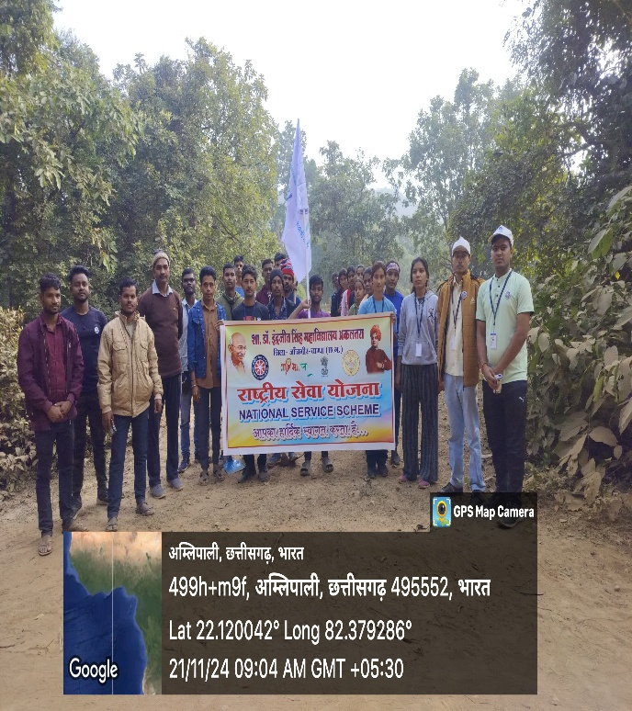
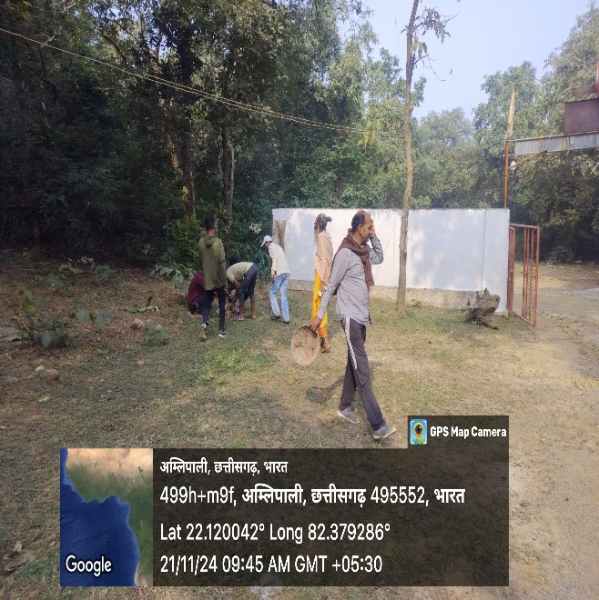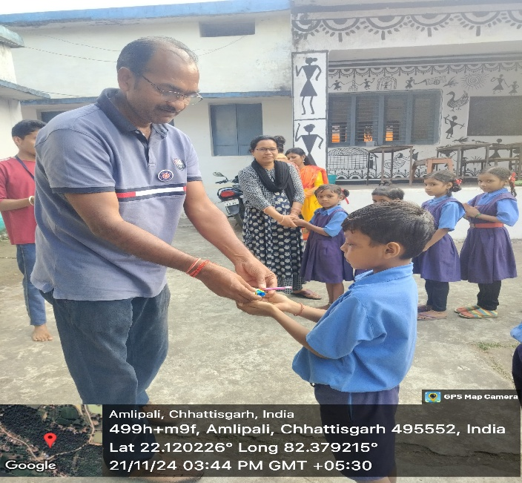
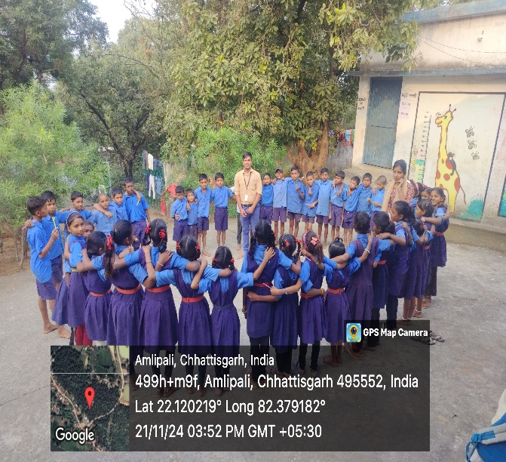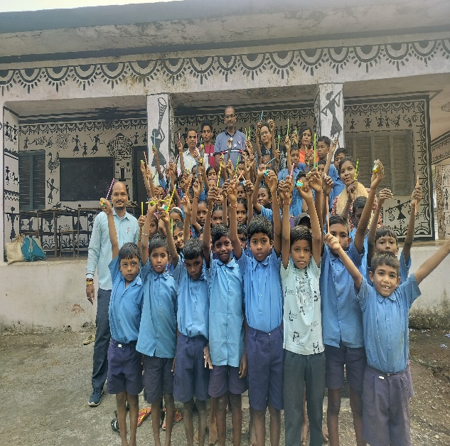
DAY-5 22/11/2024
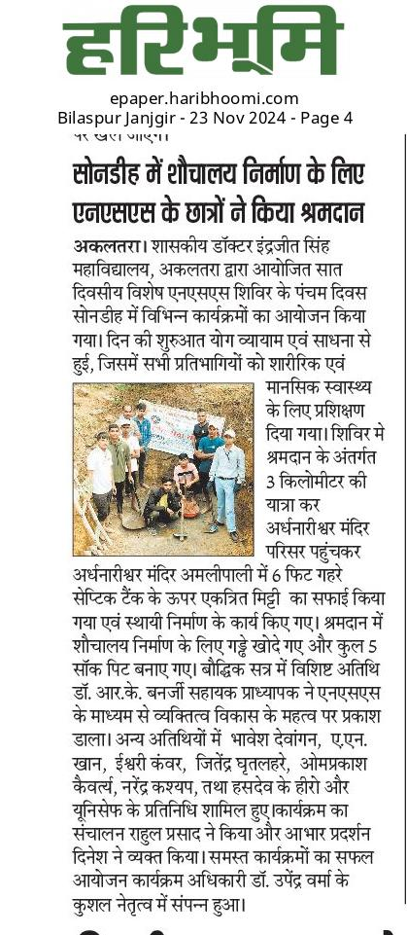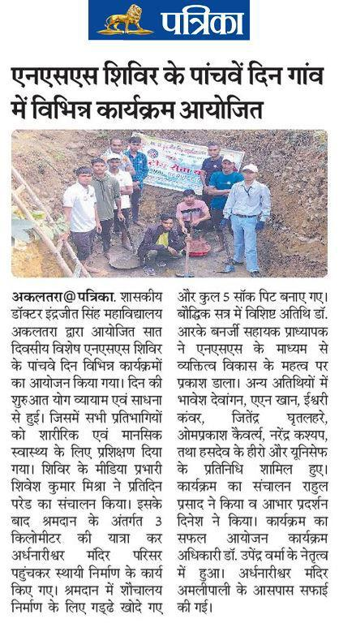
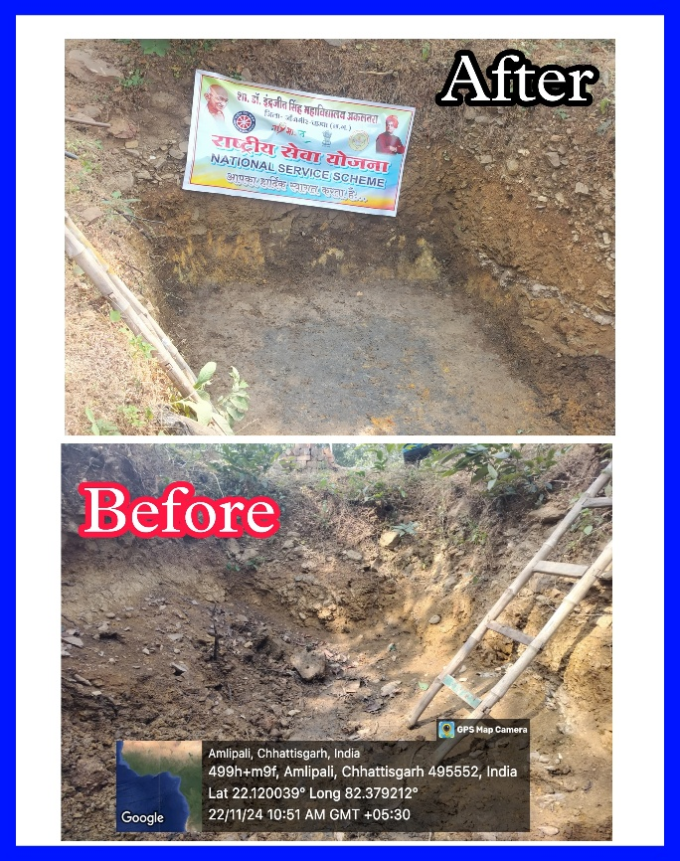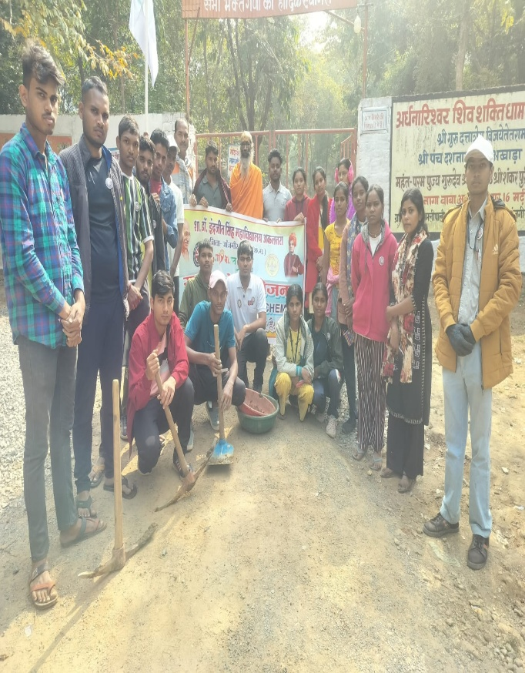
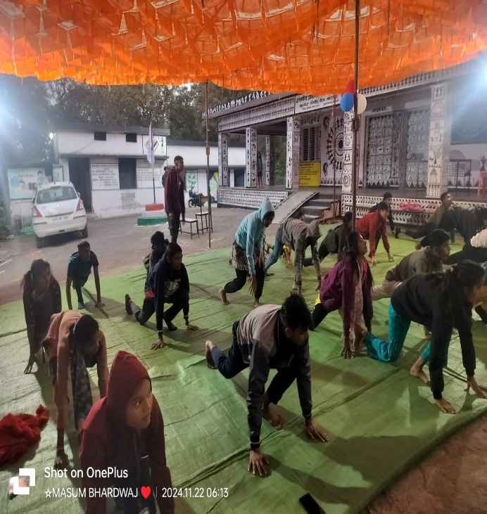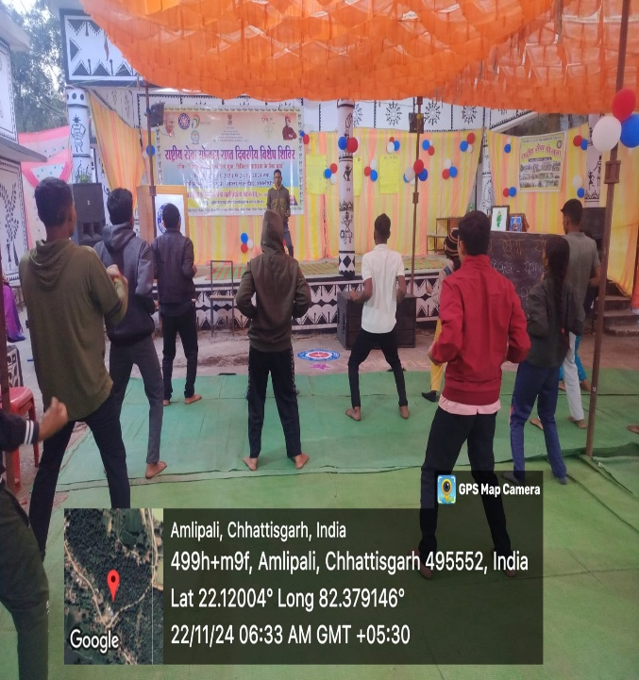
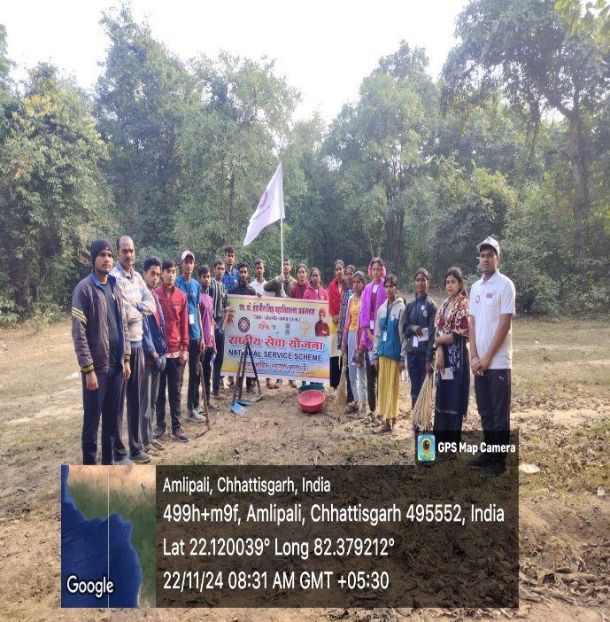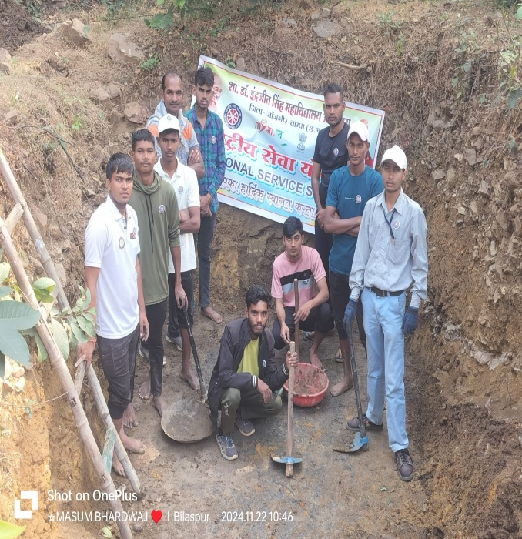
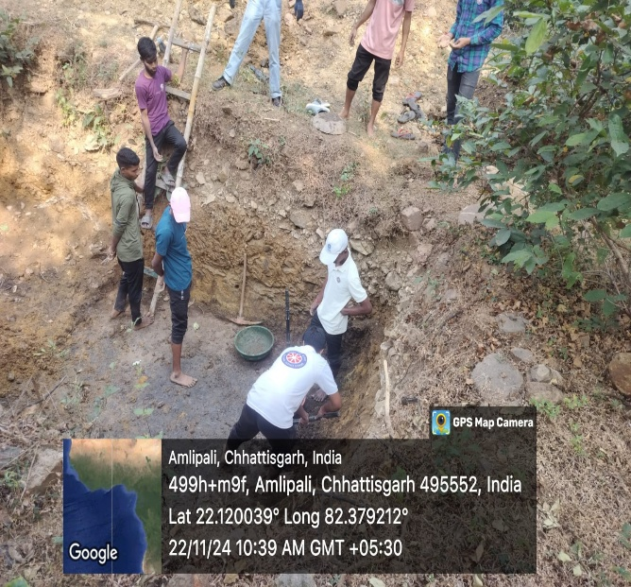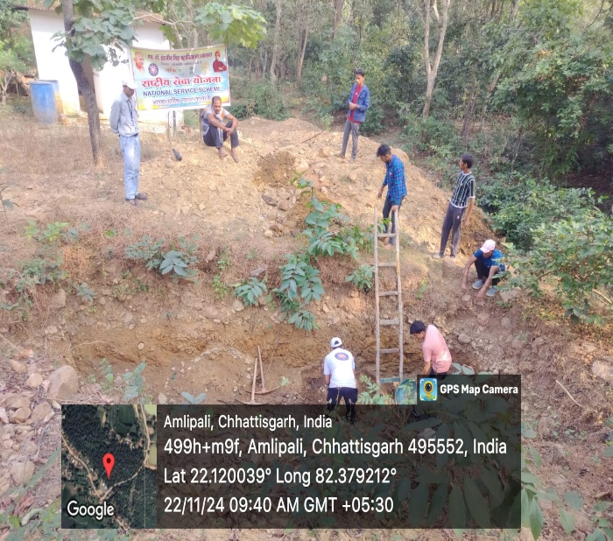
DAY-6 23/11/2024
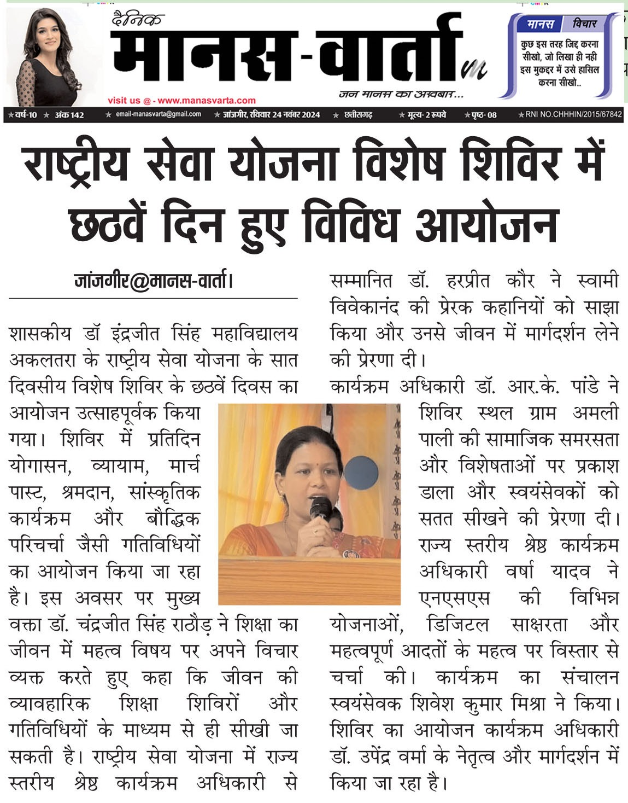
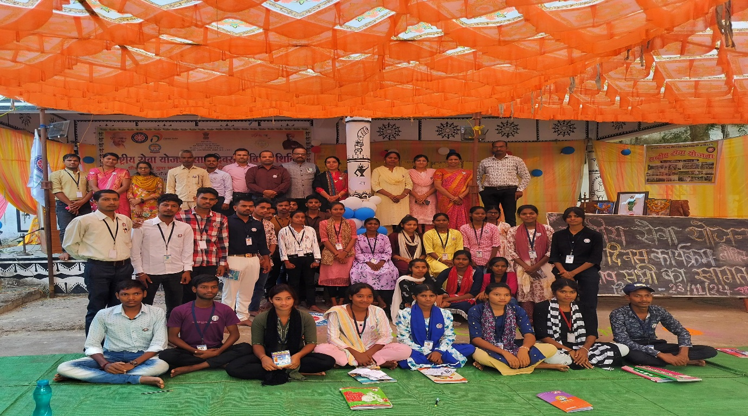
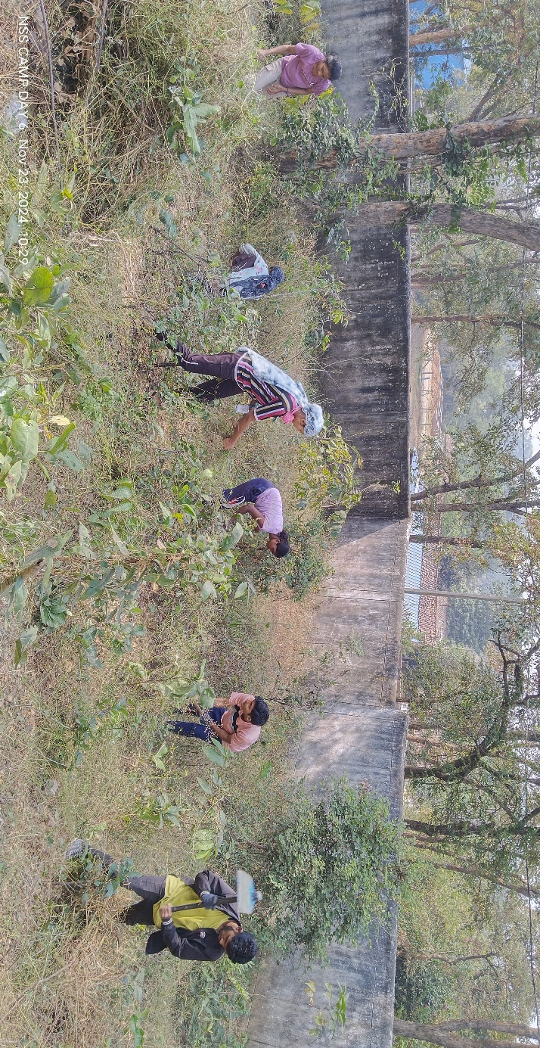
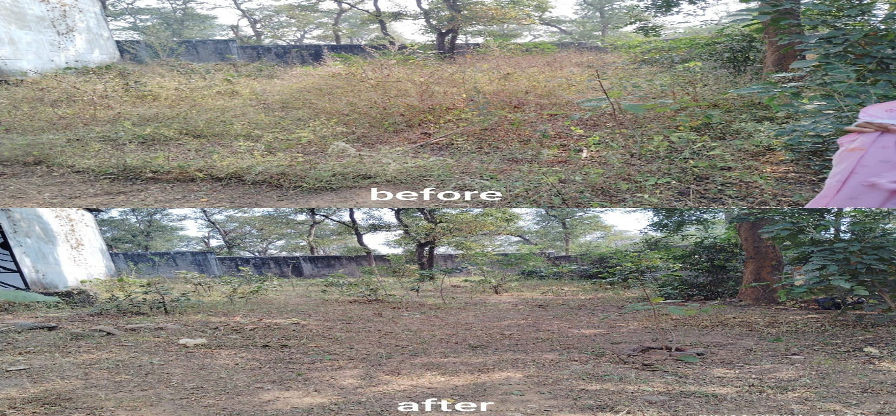
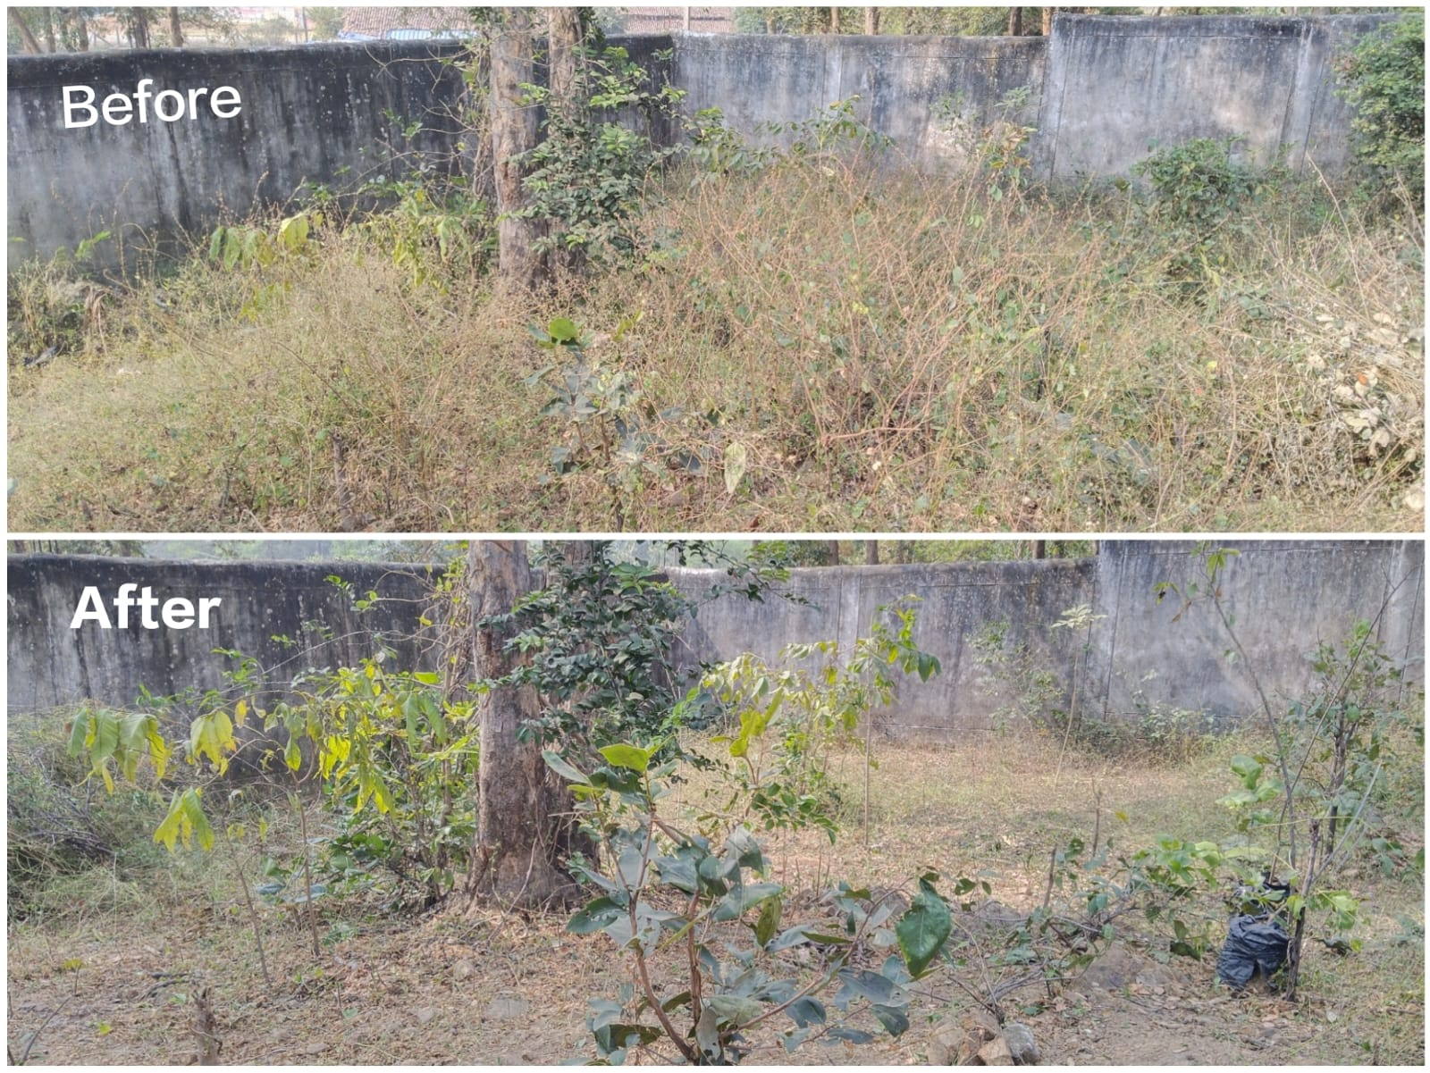
DAY-7 24/11/2024
